Travel route suggestion based on pattern of travel and difficulties

Problem Statement

The main objective of the project is to help visitors travelling from their source to destination from a database of source and destination with best possible route. This system will consider route followed by most travelers and difficulties faced by travelers for various routes.

The project will be adaptive to any new source and destination and can learn from traveler’s experiences. Like travel agents can suggest the best route/destination for travelers from their visitor’s feedback, this system will also guide the visitors for the good travel routes and destinations. The visitor’s feedback is of travel difficulties and sight seeing etc. attractions in a location liked by them. This project can be developed for a country to guide the visitors for specific cities based on their origin and then start helping them when they enter the destination for the scenic spots in that city.

Background

The project requires artificial intelligence to learn from traveler experiences and use this information in guiding future travelers to tell which route will be preferable for them. In a way youtube suggests similar videos for a video watcher this system can also suggest new places based on tickets they have previously booked using this system. Thus, it will have two-fold learning one for the previous visitor experiences and one for the pattern followed by present user.

[1] An-Jung Cheng et al. proposes travel route recommendation based on peoples attributes from photos like : gender, age, race. Authors find that people attributes are effective for making decisions on travel landmarks and paths and also helpful for route planning and personalized travel recommendation.

[2] Logesh Ravi and Subramaniyaswamy Vairavasundaram details a development of recommender systems based on travelers interests. Social data such as check-in behavior, social relationships, ratings, and recent area of work helps in the discovery of very accurate travel recommendations. Authors proposes a location recommender system comprising of four major components: UI module, recommendation module, ratings prediction module, and location based social network (LBSN). Ratings of a location are values from 0 to 1 and used by recommendation module to match the users atributes taking help of LBSN data.

[3] Takeshi Kurashima proposes a travel route recommendation method making use of photographers' histories as held by Flickr. Author recommends route by photographer behavior model, estimating the probability of a photographer visiting a landmark.

[4] Ge Cui et al. proposes two personalized travel route recommendation methods – collaborative travel route recommendation (CTRR) and an extended version of CTRR (CTRR+). Both methods uses personalized travel routes followed by users based on GPS trajectories. Users travel behaviour frequencies are estimated by using collaborative filtering technique and then imporved to get maximum probability of a route using Naive Bayes model.

Methodology

I The system can start learning from scratch using frequency of visits to various destinations from a user’s source. The most frequent destinations can be sorted by it and displayed to new traveler and suggest him/her to travel to most frequently visited destination. Slowly this system can match the preferences of a user visiting certain place who also visits another place. Thus, it will need a machine learning algorithm for training the system into two classes: similar and not similar destinations. It can count the number of persons visiting same destination for any two such places and normalize by total visitors from a source to these two places. Then this count will have a value between 0 and 1. 1 if both places are visited by same visitors. 0 if no two places are visited by same people. Based on this similarity score system will predict the user preferred routes from his/her travel history.

II The system can also predict the difficulties in any route from user’s feedback and predict about a route as difficult or easy from these feedback score (1-5) given by visitors for these places. The score is weighted averaged over all the visitors and level of difficulty is known from these values. User can be warned of difficult routes using these scores. The system can keep the previous score and number of visitors and update both values when next visitor traveled there to get a new score.

The system can also be trained based on textual feedback comments on a route from travelers. If difficult route is known, then its comments can be stored in a document which relates to difficult journey. On a smooth and nice way comments can be stored as good journey. Then logistics regression can be applied to train the system with input nodes equal to number of words possible in a sentence say 100. For each word tf-idf can be found and given to Neural Network as input and output defined for which document class is difficult and which good. When we give a new place travelers feedback then it will automatically put it into difficult or easy route. Like this user can be displayed difficulty level in any chosen route.

The difficulty of any route can be trained using input parameters like:

1. Road conditions
2. Weather conditions
3. Traffic
4. Number of accidents
5. Personality of an individual (e.g. age, gender of person)

A supervised approach (training using already known routes as difficult and easy) for Neural Network with 3-4 hidden layers and each parameter having value between 0 and 1 can be used for this project. The data for each road condition can be obtained from internet sites like: http://www.badroadsinindia.com/

Experimental Design

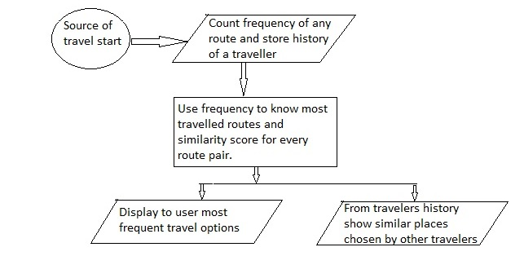
Fig 1: Architecture for suggesting a route based on travel pattern of other travelers and current user history pattern

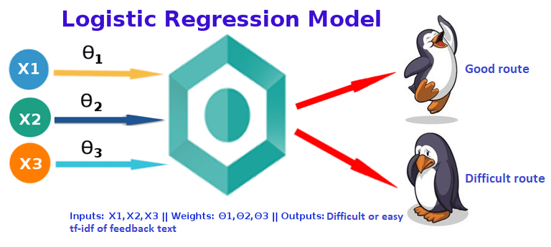
Fig 2: Architecture diagram for knowing the difficulty of a route

I Route suggestion based on travel pattern

Step 1: A database is created for storing the number of visitors going a destination.

Step 2: The frequency of visit is sorted and shown to user as most opted travel options.

Step 3: Similarity score is calculated pairwise from database with number of travelers going to both routes divided by total visitors to both routes.

Step 4: From traveler’s history similar routes are shown for ease of choosing next destination.

II Difficulty level display to user for a route

Step 1: Store the difficulty feedback of vistors for all routes in database in form of score (1-5) and/or feedback text.

Step 2: Calculate the difficulty score by summing scores and dividing by total visitors. Next time add to sum of difficulty scores and add 1 to visitor count and update the difficulty score.

Step 3: Train a Neural Network for predicting route as difficult from traveler’s textual feedback of known difficult and good routes.

Step 4: Display to new user both the difficulty scores for his ease of knowing the difficulty in taking a journey.

Evaluation Measures:

Travelers are shown correctly new routes based on travel pattern of others and his/her travel history. A high difficulty score is correctly displayed on known difficult routes.

Software and Hardware Requirements:

Anaconda with tensorflow can be used to make the logistic regression model and it can easily predict the new text class after training. Simple python logic can be used to calculate the most frequent travel locations and similar locations. Similarly, Sql Server database can be used to store the visitor history by way of routes chosen by different visitors in different dates.

Neural Network can be coded with tensorflow with sigmoid activation function and adams optimizer.

References:

[1] Personalized Travel Recommendation by Mining People Attributes from Community-Contributed Photos, An-Jung Cheng et al., Copyright 2011 ACM 978-1-4503-0616-4/11/11

[2] A Collaborative Location Based Travel Recommendation System through Enhanced Rating Prediction for the Group of Users, Logesh Ravi and Subramaniyaswamy Vairavasundaram, Computational Intelligence and Neuroscience Volume 2016 (2016), Article ID 1291358, 28 pages

[3] Travel route recommendation using geotags in photo sharing sites, Takeshi Kurashima, CIKM '10 Proceedings of the 19th ACM international conference on Information and knowledge management Pages 579-588 , Toronto, ON, Canada - October 26 - 30, 2010
[4] Personalized travel route recommendation using collaborative filtering based on GPS trajectories, Ge Cui, Jun Luo & Xin Wang, International Journal of Digital Earth Volume 11, 2018 - Issue 3

